**Stage 4 - The rifle is the first weapon you learn how to use, because it lets you keep your distance from the client**

**COURSE DESIGNER:** Ike Starnes

|  |
| --- |
| **SCORING:** Comstock 25 rounds.  **TARGETS:** 11 cardboard targets, 3 steel targets.  **SCORED HITS:** 2 Best hits per carboard will be scored. Steel must fall to score. |

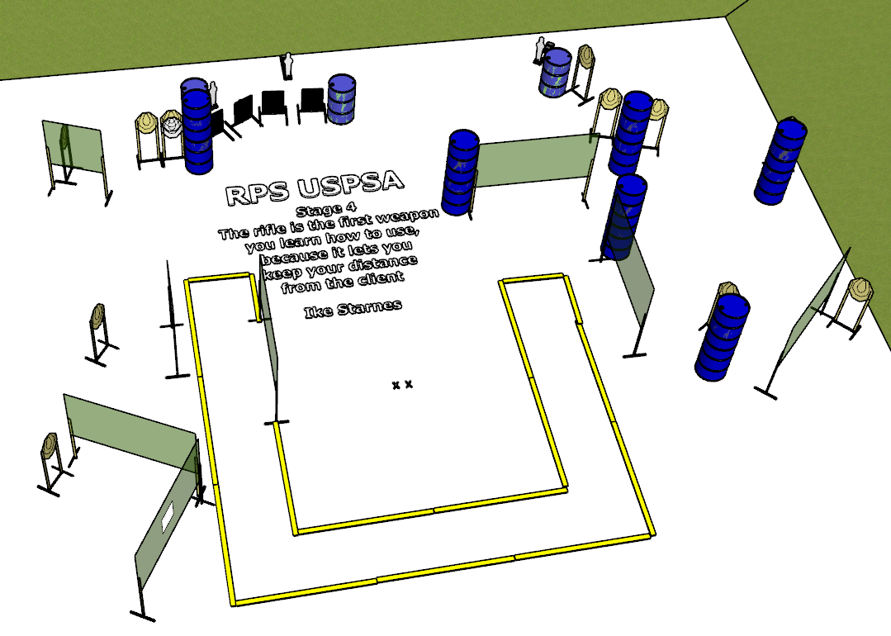

**Written Stage Briefing:**

**Stage 4 - The rifle is the first weapon you learn how to use, because it lets you keep your distance from the client -** is a 25-round, 125 point, Comstock Long Course. There are 11 cardboard targets and 3 steel targets. The best 2 hits per cardboard target will be scored. The steel must fall to score.

**Start position** Both feet on the Shooting Sports Innovations Xs, facing generally downrange.

**Handgun: Loaded and holstered, wrists below belt.**

**PCC: Loaded, held in both hands, stock touching belt.**

On the audible start signal, engage targets from within the shooting area.

**USPSA / NROI Range Commands:**

* Make Ready
* Are you ready?
* Standby
* If finished, unload and show clear.
* If clear, hammer down and holster
* Range is clear

**Setup Notes:**

14 Single Wall Stands

1 Double Wall Stand

5 Full Walls

1 Port Wall

2 Half Walls

11 Target stands / 22 target sticks

3 Mini Poppers

3 Popper Bases

4 Steel Hardcover

1 Starting Xs

15+ barrels

